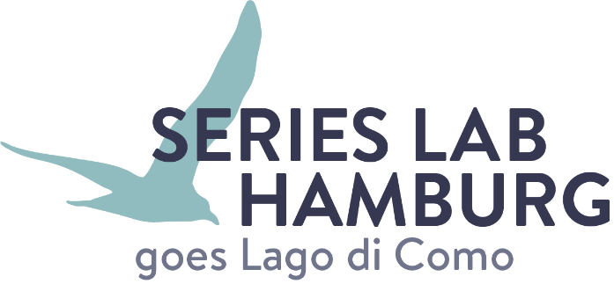

Serial Content Meets Financing
Series Lab Hamburg – Goes Lago di Como - Call for projects 2025

We are pleased to announce the 8th edition of the SERIES LAB HAMBURG – Goes Lago di Como, a development- and co-production event bringing together twenty European producers with a high-end TV drama series in development who are looking for international partners.
The event takes place live in Menaggio, Lago di Como from October 20 to 22, 2025.
Five renowned international script experts will work with the teams on their projects: Moreover, there will be a marketplace with 20 European financiers, from commissioning editors to world sales companies.
Call for projects
We are looking for producer/author teams with international production experience and an international high-end drama series in development. A minimum of financing should already be in place.
If you are interested, please contact your Creative Europe MEDIA Desk to get your application form and apply by June 3, 2025!
There is no participation fee. Participation, accommodation, and catering are covered. Travel costs are at the participants’ own expense.
We aim to follow the overarching priorities of the European Commission in sustainability and diversity within the organization of the event, the selected teams and projects.
We would be delighted to see you at Lago di Como!
Your Creative Europe Desk Hamburg, Italy and Media Desk Suisse
